24/03/21
THM 415: Finance
Midterm Exam Answer Sheet
- Why shall companies, at the end of each period, prepare an adjusting entry where a portion of fixed asset is shown as depreciation expense to be included in that very period’s income statement? (2 Points)
Companies, at the end of each period, shall prepare an adjusting entry where a portion of fixed asset is shown as depreciation expense to be included in that very period’s income statement in order to match expenses with revenues they helped to generate in the same period of time (Matching Principle).
- Bozdoğan Hotel had recorded the following income statement accounts sorted in alphabetical order:
Cost of Goods Sold | $1,903,903
Interest Expenses | $223,061
Operating Expenses | $763,705
Sales | $3,275,604

In addition, since Bozdoğan Hotel owns 53 % shares of Can Company, it is entitled to $ 1,250,253 of dividends income from that very company. Moreover, Bozdoğan hotel’s board of directors decided to distribute $ 83,760 as dividends to their shareholders.
The following table reveals Income Tax Rates for Corporate Income for 2021 fiscal year:

Taxable Income | Marginal Tax Rate
$ 0 – $ 75,000 | 14%
$ 75,001 - $150,000 | 16%
$ 150,001 - $ 300,000 | 18%
$ 300,001 - $ 500,000 | 20%
$ 500,001 - $ 750,000 | 22%
$ 750,001 - $ 1,000,000 | 24%
Over $ 1,000,000 | 30%

Lastly, the following table shows dividend income exclusion to avoid double taxation at corporate level.
Ownership Interest | Dividend Exclusion
Less than 20 % | 18%
20 % to 35 % | 28%
35 % to 55 % | 38%
55 % to 75 % | 58%
75 % to 85 % | 78%
More than 85 % | 100%

a) Construct Bozdoğan Hotel Income Statement for the year ended December 31st, 2021. (2 Points)

Moreover, the following is Bozdoğan Hotel’s comparative balance sheet as of December 31st, 2020 and December 31st, 2021:
- Construct Bozdoğan Hotel Statement of Cash Flow for the year ended December 31st, 2021. (3 Points)

- Calculate the Quality of Earnings. Interpret your result. (1 Point)
- Quality of Earnings = (Cash Flow from Operations) / (Net Income) = 112,435 / 132,407 = 84.92 %.
Thus, in 2021, Bozdoğan Hotel’s cash flow from operations was 84.92 % of the firm’s reported net income.
- Calculate the Capital Acquisition Ratio. Interpret your result. (1 Point)
- Capital Acquisition Ratio = (Cash Flow from Operations) / (Cash Paid for Capital Expenditures) = 112,435 / 114,019 = 98.61 %.
Thus, in 2021, Bozdoğan Hotel was able to finance 98.61 % of its new expenditures for plant and equipment out of the firm’s operation’s cash flow.
- Based on the income statement prepared in part a), comparative balance sheet and cash flow statement prepared in part b), analyze the financial situation of Bozdoğan Hotel for the fiscal year 2021. (3 Points)
Income Statement:
- In 2021, Bozdoğan hotel is a profitable company as its revenues (i.e. sales) are greater than its costs.
- In 2021, Bozdoğan Hotel’s mark-up on its cost of goods sold is 41.88 %.
- In 2021, for each dollar of revenue, Bozdoğan Hotel is left with 18.56 cents after deducting all its operating expenses.
- In 2021, each one dollar of sales is associated with 4.04 cents of net income.
Balance Sheet:
- Bozdoğan hotel is a highly liquid company as its net working capital is $ 875,834. This means that current assets can shrink by as much as $ 875,834 and the company would still be able to pay its current liabilities.
- In Bozdoğan Hotel, the purchases of assets are financed 48.67 % through debt and 51.33 % through equity.
- For each one dollar of net income, 36.74 cents are retained in the business.
Statement of Cash Flow:
Cash flow from operating activities:
- Bozdoğan Hotel has positive cash flows from operating activities.
- The primary contributors to the operating cash flows were net income and depreciation expense.
- Accounts receivables and accounts payable are the only contributors of cash usage.
Cash flow from investing activities:
- Bozdoğan Hotel invested $ 114,019 in purchasing fixed assets. This is roughly 101.41 % of the total cash flow generated from operations.
Cash flow from financing activities:
- Bozdoğan Hotel has positive cash flows from financing activities.
- Cash usage resulted from payment of already declared dividends, purchase of marketable securities as well as payment of short-term notes.
- The contributors to cash was the issuance common stock (par), getting a long-term note and common stock (paid-in-capital).
- Suppose you would like to triple your investment. For this purpose, you deposited in a bank $ 19,403.18 to be compounded quarterly at an interest rate of 4.24 %. Calculate the period (in years) needed to reach your objective? (1 Point)
- Interest Rate = 4.24 % / 4 = 1.06 %; Present Value = - $ 19,403.18; Payment = $0; Future Value = $ 58,209.54.
Answer: Nper (1.06 %, 0, -19403.18, 58209.54) / 4 = 26.05 Years.
Therefore, it would take 26.05 years for an investment of $ 19,403.18 to triple at an annual interest rate of 4.24 % compounded quarterly.
- After examining the various interest rates opportunities, you find that you can borrow from a finance company at 12.03 % compounded monthly, from bank A at 11.99 % compounded weekly.
a) Which alternative is the most attractive? Why? (1 Point)
- Borrowing from Finance Company: Effective Annual Rate= Effect (12.03 %, 12) = 12.72 %.
- Borrowing from bank A: Effective Annual Rate = Effect (11.99 %, 52) = 12.72 %.
Since I am borrowing, I shall choose the offer that has the lowest Effective Annual Rate. Therefore, I shall borrow from Finance Company (12.7160 % for Finance Company vs. 12.7229 % for Bank A).
b) If you wanted to consider Bank B which offers continuous compounding. What is the maximum interest rate suggested by this very bank to start thinking about the offer? (1 Point)
Bank B shall give me a maximum rate of 11.97 % to start thinking about the offer.
- Lacazette wanted to buy a home that costs $ 500,500. He took a 10-year mortgage loan with semi-annual payments at an annual rate of 4.18 %.
a) How much will Lacazette pay each period? (1 Point)
Interest = 4.18 % / 2 = 2.09 %, Period = 10 * 2 = 20; Present Value = $ 500,500; Future Value = $ 0
Answer: Payment (2.09 %, 20, 500500, 0) = $ - 30,875.43.
b) Fill in the amortization schedule. (3 Points)
Period | Amount Owed on the Principal (Beg. Period) ($) | Annuity Payment ($) | Interest Portion of the Annuity ($) | Repayment of the Principal Portion of the Annuity ($) | Outstanding Loan Balance ($)
1 | $500,500.00 | $30,875.43 | $10,460.45 | $20,414.98 | $480,085.02
2 | $480,085.02 | $30,875.43 | $10,033.78 | $20,841.65 | $459,243.37
3 | $459,243.37 | $30,875.43 | $9,598.19 | $21,277.24 | $437,966.13
4 | $437,966.13 | $30,875.43 | $9,153.49 | $21,721.94 | $416,244.20
5 | $416,244.20 | $30,875.43 | $8,699.50 | $22,175.92 | $394,068.27
6 | $394,068.27 | $30,875.43 | $8,236.03 | $22,639.40 | $371,428.87
7 | $371,428.87 | $30,875.43 | $7,762.86 | $23,112.56 | $348,316.31
8 | $348,316.31 | $30,875.43 | $7,279.81 | $23,595.62 | $324,720.69
9 | $324,720.69 | $30,875.43 | $6,786.66 | $24,088.76 | $300,631.93
10 | $300,631.93 | $30,875.43 | $6,283.21 | $24,592.22 | $276,039.71
11 | $276,039.71 | $30,875.43 | $5,769.23 | $25,106.20 | $250,933.51
12 | $250,933.51 | $30,875.43 | $5,244.51 | $25,630.92 | $225,302.59
13 | $225,302.59 | $30,875.43 | $4,708.82 | $26,166.60 | $199,135.99
14 | $199,135.99 | $30,875.43 | $4,161.94 | $26,713.48 | $172,422.51
15 | $172,422.51 | $30,875.43 | $3,603.63 | $27,271.80 | $145,150.71
16 | $145,150.71 | $30,875.43 | $3,033.65 | $27,841.78 | $117,308.93
17 | $117,308.93 | $30,875.43 | $2,451.76 | $28,423.67 | $88,885.26
18 | $88,885.26 | $30,875.43 | $1,857.70 | $29,017.73 | $59,867.54
19 | $59,867.54 | $30,875.43 | $1,251.23 | $29,624.20 | $30,243.34
20 | $30,243.34 | $30,875.43 | $632.09 | $30,243.34 | ($0.00)
c) Suppose that exactly after 5 years, mortgage interest rates fell to 4.04 %. If Lacazette has the chance to refinance his loan at that very interest, how much would he pay (on a semi-annual basis) for the remaining 5 years of the loan? (1 Point)
Interest = 4.04 % / 2 = 2.02 %, Period = 5 * 2 = 10; Present Value = $ 276,039.71; Future Value = $ 0
Answer: Payment (2.02 %, 10, 276039.71, 0) = $ - 30,762.71.
d) If such a refinance opportunity is associated with paying a prepayment penalty fee to the bank of $ 1,050, shall Lacazette refinance his loan? Why? Why not? (2 Points)
The answer to this question lies in coming up with cash flow increments by taking the difference of cash flows (for each of the remaining 5 years) between the first scenario (i.e. continuing paying $ 30,875.43) and second scenario (i.e. paying $ 1,050 as a penalty in year 0, and saving $ 112.72 for the remaining 10 six-month period). To sum up, the following table reveals the cash flow increments from opting for the second scenario:
As can be seen from the above table, paying $ 1,050 as a pre-payment penalty but start saving $ 112.72 for the remaining 10 six-month period (i.e. 30,875.43 – 30,762.71) would yield a negative return. Hence, Lacazette shall not re-finance the mortgage loan since he will be worse off when opting for the second scenario.
- Upon evaluation of the distribution of returns of İlkhan company, the following possible rate of returns for the upcoming period as long as their probability of occurrence are estimated:
Probability of Occurrence | Rate of Return on Investment
5% | -10.53%
10% | -6.78%
15% | -3.14%
23% | 1.33%
18% | 4.04%
16% | 8.75%
13% | 14.24%
a) Calculate the Expected Rate of Return of İlkhan Company stock. (1 Point)
- Expected Rate of Return = (5 % * - 10.53 %) + (10 % * - 6.78 %) + (15 % * - 3.14 %) + (23 % * 1.33 %) + (18 % * 4.04 %) + (16 % * 8.75 %) + (13 % * 14.24 %) = 2.61 %.
b) What is the risk of the investment in İlkhan Company stock as measured using the standard deviation of possible future rates of return? (2 Points)
- Serdar bought some stocks of Saatçı Company worth of 1,000,000 Euros 8 years ago. Following is the beginning value of Saatçı bought stocks 8 years ago as well as the values at the end of each year up until today (the end of year 8):
Year | Stock Value (Euros)
0 | 1,000,000.00
1 | 954,700.00
2 | 929,400.45
3 | 976,335.17
4 | 1,076,214.26
5 | 1,164,033.34
6 | 1,200,583.99
7 | 1,281,743.47
8 | 1,269,054.21
a) What will be the annual rate of return that Serdar expects to earn next year, if he plans to continue holding Saatçı Company stocks? (1 Point)
- Annual rate of return that Serdar expects to earn next year, if he plans to continue holding Saatçı Company stocks = (- 4.53 % - 2.65 % + 5.05 % + 10.23 % + 8.16 % + 3.14 % + 6.76 % - 0.99 %) / 8 = 3.15 %.
b) What annual rate of return that Serdar expects over a four-year horizon from holding Saatçı Company stocks? (1 Point)
- Annual rate of return that Serdar expects over a four-year horizon from holding Saatçı Company stocks = ((1 + 8.16 %) * (1 + 3.14 %) * (1 + 6.76 %) * (1 - 0.99 %)^^{(1/4)}) – 1) = 4.21 %.
- You own a portfolio consisting of the following stocks:
Assume the risk-free rate is 3.14 % and the expected return on the market portfolio is 19.65 %.
- Calculate the expected return of your portfolio. (0.50 Points)
- Expected return (Portfolio) = (14 % * 16 %) + (33 % * 17 %) + (20 % * 20 %) + (18 % * 12 %) + (15 % * 23 %) = 17.46 %.
- Calculate the portfolio beta. (0.50 Points)
- Beta (Portfolio) = (14 % * 0.76) + (33 % * 0.83) + (20 % * 1.03) + (18 % * 0.58) + (15 % * 1.24) = 0.88.
- Plot the security market line on a graph. (2 Points)
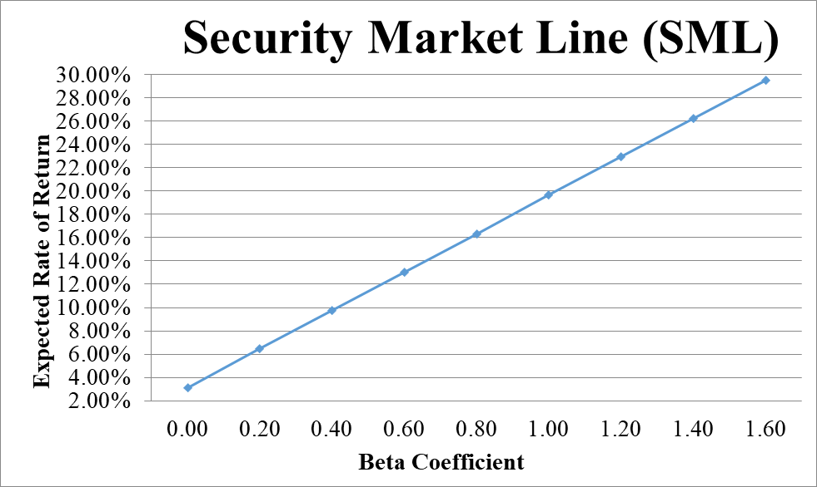
- From your plot in part c, which stocks appear to be your winners, and which ones appear to be losers? Explain the reason behind your conclusion. (2 Points)
- Why should you consider your conclusion in part d) to be less than certain? (1 Point)
This conclusion is based on our having the right betas. Recall that calculation of Betas are subjective (i.e. depend on the market to be chosen, sample size, time interval chosen, definition of period…). If all of our betas understate their stock’s systematic risks, then we would be underestimating our portfolio risk.
GOOD LUCK!

